Thailand Rail Freight Demand and Opportunities:

Southern Line Approach

Oranicha Buthphorma and Thammanoon Hengsadeekulb

a,b School of Logistics and Supply Chain, Naresuan University

Abstract

Keywords: Rail Demand, Rail Freight, Economic Opportunities, Infrastructure and Strategy, Southern of Thailand

1. Introduction

Railways well know as long distance winners as long distances freight transport id constantly growing. The significance of rail freight over large distance is noticeably on the rise, as North America, Australia, the goal is to get the freight to its intended destination as quickly efficiency as possible. Rail freight transportation is based on the realization of added values of the entire rail freight system, while the realization of added values is based on the collaboration between subsystems of the entire freight system (Feng et al, 2015). Tracking the Power of Rail Supply: The Economic Impact of Rail Suppliers in the U.S. A new report from Oxford Economics has found that the railway supply industry’s total contribution to U.S. gross domestic product (GDP) in 2017 was $74.2 billion, which highlights the industry’s significant economic impact, said industry stakeholders. Chen and Qin (2014), considered logistics industry and rail freight is induced variables, social economic activities. International, Thailand is still gain competitiveness in order to contribute nation economic sustainability. Logistics cost have become key driver and direct impact to GDP. Thailand aim to decrease logistics cost to GDP from 13.8% in year 2018 to 12% of GDP by 2021. In conclusion, it is clear that rail transport is an intelligent and sustainable driver of GDP.

2. Transportation and Rail Freight: An Overview

Transport plays an important role in today's economy and society and has a large impact on growth and employment. The transport industry directly employs around 10 million people and accounts for about 5% of gross domestic product (GDP). The quality of transport services has a major impact on people's quality of life. On average 13.2% of every household's budget is spent on transport goods and services. ([https://ec.europa.eu](https://ec.europa.eu/jrc/en/research-topic/transport-sector-economic-analysis))

The reality is that transportation plays a broad role in shaping economies; supports cluster and agglomerations, increase productivities, enhances jobs and labour market accessibility, opens new markets for business and enhances supply chain efficiency (Dowell, 2017). Meanwhile, Aschauer’s (1989), studies established on a statistic links between economic growth and transport infrastructure in various countries in the past few decades. Railroads constitute an important mode of transport for both freight and passengers. In the United States, for example, railroads are responsible for 35.6% of total intercity freight transport and enjoy approximately 30% of total revenues of all carriers ([Assad](https://www.sciencedirect.com/science/article/abs/pii/0191260780900175#!) ,1980).

The global rail freight transport market was valued at USD 302.05 billion in 2018. North America leads the global rail freight market and Asia-Pacific is expected to overtake North America during the forecast period. In addition, the rise in global trade and various trade agreements are boosting the global trade flows. In some regions of Central Asia, Eastern Europe, South Asia, Southeast Asia, and Sub-Saharan Africa characterized by groupings of many small countries, rail freight can increase economic integration by providing access to international and regional markets and connecting landlocked countries. (<https://www.giiresearch.com>)

The [Global Railway Management System Market](http://databridgemarketresearch.com/reports/global-railway-management-system-market/) accounted for USD 30.3 billion in 2016 growing at a CAGR of 15.2% during the forecast period of 2017 to 2024. The upcoming market report contains data for historic year 2014, 2015, the base year of calculation is 2016 and the forecast period is 2017 to 2024. ([https://wiseawareness.com](https://wiseawareness.com/global-railway-management-system-market-analysis-full-in-depth-analysis-by-new-trend-regional-analysis-share-size-application-growth-and-global-forecast-to-2025/))

Positive impetus will come from rail freight transport. China is also experiencing a restructuring within the freight market, in that there is a decline in transport in the heavy industry and a shift to lighter goods in containers, which is promoted through the improvement of framework conditions for the railway. The goal is to reduce environmental pollution in cities and to increase the portion of rail freight to 30%. This will positively affect the procurement of new rail freight rolling stock, flexible transport systems and environmentally-friendly locomotives. ([https://www.sci.de)](https://www.sci.de/fileadmin/user_upload/MC_Studien_Flyer/Flyer_MC_Worldwide_Market_2018_eng.pdf)

Rail transport in Thailand has been dependent since 1951 on the State Railway of Thailand (STR) and rail transport is going more and more important in Thailand. In 1951, the government lead by Chom Phon Por Pibulsonggram, as Prime Minister, has agreed to manage the train operation separately, so they have proposed a draft law to Parliament Railway of Thailand, and have enacted a statutory enactment, to be announced in the Government Gazette, dated 30 June 1951, the Royal Train as it changed to the type of public enterprises under the name of "The Train Operation of Thailand" from 01 July 1951 onwards, operating under the Act., of the railway company 1951. Thai railways transport both bulk freight (primarily oil products and construction materials) and containerized freight. Most of the freight movement is between Bangkok and sea ports (in particular, between the deep water port of [Laem Chabang](https://en.wikipedia.org/wiki/Laem_Chabang) and the container terminal in [Lad Krabang](https://en.wikipedia.org/wiki/Lad_Krabang), in Bangkok's eastern suburbs).

The Thai Economy is finally showing signs of recovery after a long recession, anyway it still not clearly how the economy will equally and create fare in the future. The ability to reduce transportation costs by 4 times from double track trains Reduce costs as much as possible, making logistics operators and consumers are turning their attention to rail freight. National policy on the development of the railway system for competitiveness and competitive advantage. The transportation of goods within Thailand for the years 2009 - 2016 has been continuously growing at 5.4 and 4.3 percent respectively. While the Thai rail structure is lacking restoration to be in a position ready to support the transportation of goods and passengers Resulting in a decrease in the volume of rail transportation during 2011 and 2014.

Fig. 3: Thai rail freight volume statistics 1986-2016

Source: Calculation

Figure 3, the statistics of volume and trend of Thai rail freight from 1986-2016, which found that on average the volume has increased, but if compared with all transportation, it can be seen that the percentage of rail transportation is lower. Due to limitations on various traditional factors, problems and obstacles of Thai rail transportation Roads and rail systems Freight is still ineffective and unable to meet the needs of users. Thai railways transported around 11 million tons of freight per year in 2007-2012, which was around 2% of the total amount of freight moved by all modes of transportation. While it is possible for freight trains to travel between Thailand and the neighbouring countries (Malaysia and Laos), the amount of international rail freight presently constitutes only a minuscule portion of Thailand's foreign trade.

Fig. 4: Rail Freight Volumes by Commodity (Fiscal 2008-2015)

Source: Calculation

Thai railways transport both bulk cargos as primarily oil products, cement and construction materials and containerized freight with miscellaneous goods. From figure 4,

The table below gives the information of rail FCL freight in Thailand 2003-2017.

Fig. 5: Volume of rail transport in each region of Thailand 2003-2017

Source: Calculation

Figure 5, this statistic shows the freight rail volume of east region is highest volume between 2003-2010, it allows comparisons between the number of freight transportation from 2003-2017. The prominence of rail transport volume in the East was highest. Most of the freight movement is between Bangkok and sea ports (in particular, between the deep water port of [Laem Chabang](https://en.wikipedia.org/wiki/Laem_Chabang) and the container terminal in [Lad Krabang](https://en.wikipedia.org/wiki/Lad_Krabang), in Bangkok's eastern suburbs).

In addition to increased cross-border trade, there is another significant trend in logistics that is happening globally, especially in the Asia-Pacific region. According to a Third-Party Logistics Study (or 3PL), global usage of 3PL in the Asia-Pacific Region was roughly THB 24 trillion (USD 689 billion) in 2014, with strong growth of 16.3% over the past five years.

3. Governing Rail Freight Infrastructure Strategy in South of Thailand

Thailand locates geographic in a beneficial position, as the hub of northern South East Asia. Thailand is in the deep of an ambitious railway development drive aimed at halting the country away from automotive to more eco-friendly train transportation while transforming into a regional rail hub. Thailand has the probable to shift system for trade in the full-length region and beyond. Virtually all significant trade movements among the high value countries of the region, People’s Republic of China (PRC), Malaysia, Singapore and Thailand transit through Thailand. Requires of a combined transport system is now affecting the aggressive position of Thailand compared to its neighbours. Thailand on track to develop into regional rail hub, Government’s key aim is to boost efficiency and upgrade standards for international shipping in terms of velocity, safety and reliability and to aid economic growth within a framework of regional cooperation and to scale down the country’s overall logistics cost. As other countries modernize their railway infrastructure and operations, continued enhanced trade will also base on Thailand improving its physical interconnectivity – both through increased conventional railway networks as well as potential highspeed railway connections - to other countries in the region.

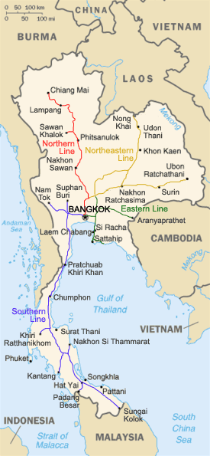

Fig. 6: Thailand railway development plan

Source: <https://www.wikiwand.com/th/>

Shortcoming of freight wealth, rail freight, which is cheaper—only roughly half the cost of road transport—safer, and more environmentally-friendly than road transport, accounted for only 1.39 percent of freight tonnage carried in 2017. SRT aims to boost its share of cargo transport to six percent with its double track expansion by 2022 (Table 1). Expansion of SRT's freight service, which could benefit more money than the heavily subsidized passenger service, has been neglected for more than 50 years in favour of Thailand's roads.

Table 1 Southern double track expansion by 2022 Project

|  |  |  |
| --- | --- | --- |
| Route | Distance (Km) | Expected completed |
| 1. Nakhon Pathom- Hua Hin | 165 | 2018/2022 |
| 2. Hua Hin - Prachuap Khiri Khan, | 90 | 2018/2022 |
| 3. Prachuap Khiri Khan - Chumphon | 167 | 2018/2022 |
| 4. Chumphon - Surat Thani | 168 | n/a |
| 5. Surat Thani- Hat Yai, | 324 | n/a |
| 6. Hat Yai - Padang Besar (Thai). | 45 | n/a |
| Total | 959 |  |

The State Railway of Thailand (SRT) is planning to spend nearly 90 billion baht to enhance the current single-track railways leading to the deep south to double tracks to cut down travel times for passengers and encourage tourism to the region. [Thailand](http://www.nomadicnotes.com/thailand/) currently has a good network of railways so most improvements will be made by double-tracking and futuristic presenting lines. There are a few high-speed proposals, including a Shinkasen-style bullet train. Regulation studies and creating a master plan for the development of the railway network to support the special economic zone to support the development of railway infrastructure in various regions and increase service capabilities, promote the rail system to be the main travel network provides to connect the transportation of goods covering important economic areas of the country through dividing the master plan into 3 phases. Railways Infrastructure line in South of Thailand, the project will be integrated with the SRT's ongoing double-track upgrades in Nakhon Pathom to Chumphon, which will benefit rail passengers and freight heading to the southern provinces of Surat Thani, Songkhla, as well as the Malaysian border town of Padang Besar.

4. Thailand Cargos Demand and Trend

Thailand freight and logistics market are expected to reach a market value of USD 122 billion by 2023, registering a CAGR of 6.08% during the forecast period (2018 - 2023). More than 80% the market is handled by road haulage. Despite, trucking company use roads that are generated and maintained by private company and funs, they pollute the air, besides to road congestion and cause traffic accidents. Whereas, they offer door-to-door service convenience and flexible schedule routing, explaining why they have cornered maximum portion more than 80% of Thailand’s transportation market. Even though, trucking plays the significant role in goods distribution in Thailand, it’s leads to serious accidents, and emit nitrogen oxides (NOx), suspended particulate matter (SPM), and other pollutants.

Table 1: Domestic Freight Volume 2009 - 2017

Unit: Thousand Tons

|  |  |  |  |  |  |  |  |  |  |
| --- | --- | --- | --- | --- | --- | --- | --- | --- | --- |
| Mode of transport | Year | | | | | | | | |
| 2009 | 2010 | 2011 | 2012 | 2013 | 2014 | 2015 | 2016 | 2017 |
| Road | 423,677  (83.66%) | 420,449  (81.36%) | 406,538  (80.42%) | 458,781  (81.86%) | 458,828  (81.39%) | 465,020  (81.18%) | 482,358  (80.82%) | 486,743  (81.12%) | 743,463  (87.51%) |
| Rail | 11,517  (2.25%) | 11,288  (2.18%) | 10,667  (2.11%) | 11,849  (2.11%) | 11,920  (2.11%) | 10,887  (1.90%) | 11,541  (1.93%) | 11,970  (1.99%) | 11,882  (1.39%) |
| Waterway | 41,561  (8.11%) | 48,185  (9.32%) | 46,932  (9.28%) | 47,423  (8.43%) | 47,422  (8.41%) | 50,113  (8.75%) | 50,907  (8.53%) | 50,327  (8.39%) | 94,120  (11.08%) |
| Coastal | 35,692  (6.96%) | 36,731  (7.11%) | 41,273  (8.16%) | 44,263  (7.87%) | 45,441  (8.06%) | 46,673  (8.15%) | 51,872  (8.69%) | 50,894  (8.48%) |  |
| Air | 104  (0.02%) | 121  (0.02%) | 131  (0.03%) | 130  (0.02%) | 120  (0.02%) | 115  (0.02%) | 117  (0.02%) | 122  (0.02%) | 137  (0.02%) |
| Total | 512,551 | 516,774 | 505,541 | 562,446 | 563,731 | 572,808 | 596,795 | 600,056 | 849,602 |

Source: OTP., 2017

The above table shows, figures of domestic transportation in period of 9 years (2009-2017), with road haulage, rail, waterway, and portion is about 80%, 2%, and 16% respectively, meanwhile air transportation very smallest portion is only 0.02%. Anyhow, the volume of all mode of transportation is increasing steady, but with the major portion is by road transportation, which high energy consumption, cause congestion, pollution and high accident, the complex and inefficiency operation as those mentioned, undoubtedly logistics cost portion to GDP of Thailand are far behind developed countries as figure below.

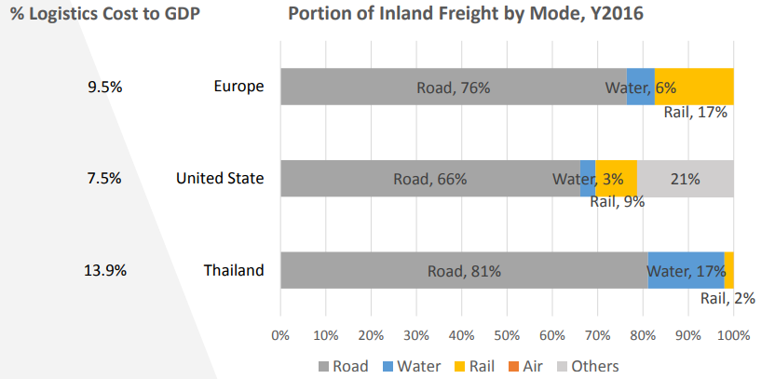Figure 1: Comparison of Logistics cost and inland freight by mode

Source: www.tma.or.th

The above figure shows data in the year of 2006 that the logistics cost per GDP in EU countries, USA and Thailand are 9.5%, 7.5% and 13.9% respectively, in the same way the portion of road haulage are 76%,66% and 81% with rail by 17%, 21% and 2% accordingly.

The demand for freight transport is strongly coupled to economic activity, and in many countries growth of demand outstrips GPD growth (Essen, 2009). The dawn of the new millennium will not change the fact that Thailand’s logistics market is an essential part of the national economy. The drive for environmentally friendly transportation systems will certainly increase and with the event of innovation and technology, customers will even have more perception to demanding the optimum transportation services. So that, logistics and freight carriage are to face the challenges of this new business external environment, of course they need to work toward to reformation and rationalization of the whole logistics system, also devise new techniques and strategies assist to be survivors.

Table 2: Forecast of Domestic Transportation

Thousand tons / year

|  |  |  |  |  |
| --- | --- | --- | --- | --- |
| Mode of Transport | 2022 (%) | 2027(%) | 2032(%) | 2037 (%) |
| Road | 795,024 (87.26) | 850,576 (87.88) | 910,010 (87.30) | 973,597 (87.47) |
| Railway | 15,244 (1.67) | 16,364 (1.70) | 17,601 (1.70) | 18,955 (1.70) |
| Waterway | 100,647 (11.04) | 100,680 (10.40) | 114,520 (10.99) | 120,273 (10.81) |
| Air | 147 (0.02) | 157 (0.02) | 168 (0.02) | 180 (0.02) |
| Total | 911,062 | 967,777 | 1,042,299 | 1,113,005 |

Source: National Model for Transport and Traffic (NAM)

National model forecasts for NAM (Bureau of Transport and Traffic Policy and Planning) data- based years 2012 and 2013, forecasts for 2022, 2027, 2032 and 2037 with the NAM model analysis product groups and product movements, freight forwarding analysis and forecasting of freight volume data, domestic transportation and freight cost classified with 180 products types transportation survey in 2016. (Office of Transport and Traffic Policy and Planning). The demanding of rail freight slightly increasing comparison with road haulage is obviously increase from the present about 80% in 2019 to 87% in 2022-2037. Whereas, the waterway (Waterway and coastal) transport forecasting to slightly decreasing from 16.41 in 2016 to average 10.81 in 2022-2037.

Overall, total volume increasing trend from 2022 to 2027, 2027 to 2032 and 2032 to 2037 are 56,715, 74,522 and 70,706 Ton respectively. But the forecasting volume from 2016 to 2022 is 311,006 Ton, (600,056 to 911,062) average 51,834.33 Tons/year.

Anyhow, the volume of inland transportation forecasting by NAM and the actual value in various period shows as below table.

Table No. 3 Forecast and actual volume of transportation

Thousand tons / year

|  |  |  |  |  |  |  |  |  |  |  |
| --- | --- | --- | --- | --- | --- | --- | --- | --- | --- | --- |
| Mode of transportation | 2012 | | 2013 | | 2017 | | 2022 | 2027 | 2032 | 2037 |
| Forecast | Actual | Forecast | Actual | Forecast | Actual | Forecast | Forecast | Forecast | Forecast |
| Road | 405,934 | 458,781 | 704,013 | 458,828 | 743,463 | 486,743 | 795,024 | 850,576 | 910,010 | 973,597 |
| Rail | 10,848 | 11,849 | 11,252 | 11,920 | 11,882 | 11,970 | 15,244 | 16,364 | 17,601 | 18,955 |
| Waterway | 88,074 | 91,686 | 89,126 | 92,833 | 94,120 | 101,201 | 100,647 | 107,680 | 114,520 | 120,273 |
| Air | 57 | 130 | 130 | 122 | 137 | 122 | 147 | 157 | 168 | 180 |
| Total | 504,913 | 562,446 | 804,521 | 563,733 | 849,602 | 600,056 | 911,062 | 967,777 | 1,042,299 | 1,113,005 |

Thailand has approaching to strategy for the development of the Thai transportation system for 20 years. The mission is to develop the Thai transportation system in the future. Supports lifestyle changes Travel behaviour, there are 3 related issues which are Green Transport, Transport Efficiency, and Inclusive Transport (Office of Transport and Traffic Policy and Planning, 2017). These developments are being promoted by the need for greater management efficiency as well as by the movement to internationalize and to rationalize distribution systems. As other industries, transportation and distribution business is faced with the need for structural reform. The rail freight carriers now face more hurdles than before as the demand for consumer-friendly distribution systems grows. By information technologies have been developed over decades as a way to boost transportation effectiveness and efficiency, the trend is commitment between manufacturer industries, which have embraced supply chain management principles in the expectation to optimization in whole aspect of their operation from sourcing, purchasing, procurement to production to shipping. So, since these developments, customers now more hope to receive cargos faster even while freight carriage fees have tended to decline. In the other hand, the volume of rail freight goods transported in Thailand shows no signal of increasing. Although, the challenges for rail freight carriers if far from stability.

Rich et al (2009) investigate this so-called structural inelasticity, i.e. the cases where substitution between modes is not possible, and conclude that particularly for origin-destination pairs below 500 km this inelasticity is very significant.

MODAL SHIFT

Besides empty running, part of the difference in emissions can also be caused by poor access to rail links by road. In short, even if the modal shift target is realised, this is not yet a sufficient condition for reducing GHG emissions per tonne.

As SRT, Railways Infrastructure project in South of Thailand,

Table 2 Expected Freight Demand in Southern Railways Line

|  |  |  |  |  |
| --- | --- | --- | --- | --- |
| Route/Year | 2022 | 2027 | 2032 | 2037 |
| 1. Nakhon Pathom- Hua Hin |  |  |  |  |
| 2. Hua Hin - Prachuap Khiri Khan, |  |  |  |  |
| 3. Prachuap Khiri Khan - Chumphon |  |  |  |  |
| 4. Chumphon - Surat Thani |  |  |  |  |
| 5. Surat Thani- Hat Yai, |  |  |  |  |
| 6. Hat Yai - Padang Besar (Thai). |  |  |  |  |

### The forecast measure in the demo model is quite an advanced amount, there are just a couple of interesting notes about the trend is after double rail track project completed (2022), the trend of rail freight slightly increasing dramatically and are many advantages of rail freight, which are not found in road transport;  Rail freight is has a lower fuel costs compared to road transport, a safe, efficient and environmentally friendly transport solution with cheaper transportation cost though High capable of hauling large loads room for more items, reliable and stable departure and arrival times, on time delivery with avoid traffic and driving bans and. Obviously, rail transport can be a very efficient solution for logistics and supply chain.

<https://www.ctc-n.org/technologies/modal-shift-freight-transport>

5. Rail Freight Challenges and Opportunities

As tremendous potential to influence large segments of the receivers of deliveries and, ultimately, freight traffic. The first challenge is related to finding out what is the best way to induce the desired behaviour al changes on the part of the receivers. This necessitates the assistance of freight behaviour research to determine, among others:

The second challenge of engagement of the private sector. As the experiences of the OHD project clearly indicates—even when a company had already committed to participate in the program—it took them a while to find the time to take the step. In brutally competitive environments, it is difficult for the private sector to take time out to enact changes in their operations. The public sector must be patient and mindful of the importance of gently pushing the private sector towards changing their practices. Business associations, Business Improvement Districts, and industry leaders could play a key role by providing guidance, examples to follow, and assurances about the overall benefits of the efforts.

A third challenge is institutional in nature. In most cases, city agencies have jurisdiction over different aspects of the urban economy. Public roads and traffic control are typically the responsibility of a city department of transportation; mass transit is routinely assigned to a transit agency; while land use, economic development, and even finance/tax agencies regulate the commercial activities performed by commercial establishments. Since the latter type of agency is the one with inherence on the receiver of supplies, inter-agency cooperation is needed to ensure FDM initiatives succeed. However, this could be a challenge because these agencies—the ones with the power to influence the behaviour of receivers by means of incentives, pricing, taxation, and the power of licensing—may not understand, or agree, that they have a role to play in using these powers to foster changes in supply chains. The private sector and community leaders—intrinsically interested in the implementation of initiatives that increase quality of life and economic conditions—could play a key role in pushing for an appropriate level of inter-agency cooperation. In spite of these challenges, however, there shall be no doubt about the importance of successful implementation of FDM. The potential benefits of holistic FDM initiatives are such that more than justify overcoming the challenges already identified. After all, FDM may hold the key to new paradigms of urban freight systems that improve economic productivity and efficiency; and enhance environmental sustainability, quality of life, and environmental justice.

The growth of freight forwarding in Thailand was supported by development in major industries such as manufacturing, retail, automobiles and agriculture. Expanding FMCG sector, retail sector, food and E-commerce industry in the country has attributed to the growth of the freight forwarding industry in the country. The freight forwarding industry in Thailand has grown at 5 years positive CAGR in the review period 2012-2017.

The Thai government's focus on improving the sectors including infrastructure development, the restructure of the rail freight market under the transport infrastructure development strategies 2022 will see the development of the cargo transport market via railways and increase the role of rail freight, particularly in key economic zones as well as the remote areas.

Flow Corridors

Asia flow corridor was observed to be the largest contributor in terms of revenue in Thailand freight forwarding market in the year 2017. In accordance with International Trade Centre, Thailand's import to Asia as well as export from Asia was recorded as of 2017 in comparison with other regions such as NAFTA countries, Europe, and others. The Thailand-Europe flow corridor followed Thailand-Asia with a double-digits share in the year 2017. Other major flow corridor includes the NAFTA countries which have been counted as emerging trading partners for Thailand.

Bangkok in the central region is drawing interest from a number of global investors seeking office / commercial space, retail and hospitality investment opportunities coupled with a high rise in buildings and a number of shopping centre in the city. The city is well connected with the rest of the world through air and sea routes and thereby, drawing huge foreign investments from international players to various sectors.

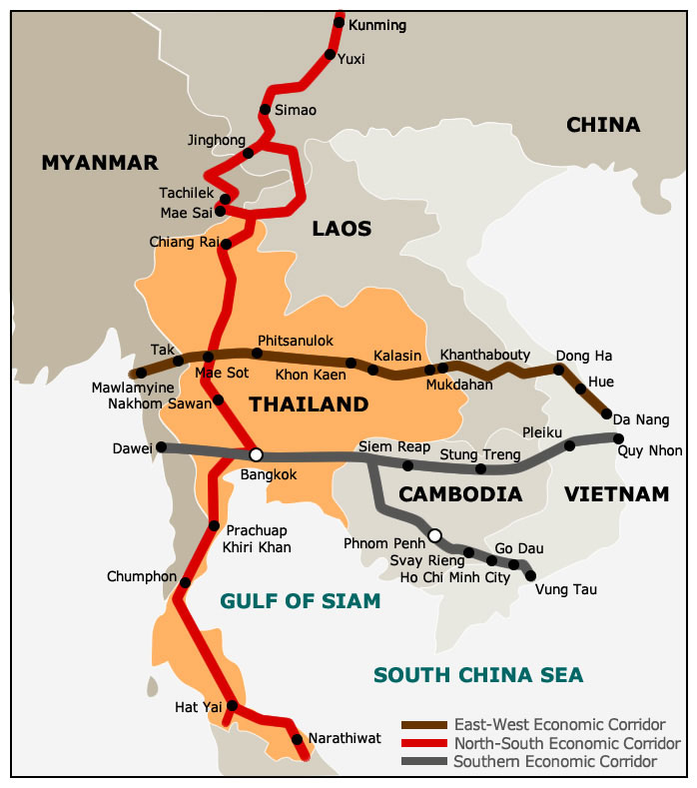

Fig. 8:

<http://economists-pick-research.hktdc.com/>

6. Concluding remarks

Acknowledgements

Appendix

References

Essen, H. van O. Bello, J. Dings, R.van den Brink (2003) To shift or not to shift, that's the question. The environmental performance of freight and passenger transport modes in the light of policy making. Delft, CE, March, 2003. <http://www.ce.nl/publicatie/to_shift_or_not_to_shift%2C_thats_the_question/66>

Rich, J., O. Kveiborg, C. Hansen (2009) On structural inelasticity of modal substitution in freight transport. Journal of Transport Geography (2009)